5E SECTION I: Lesson Plan
Standards & Objectives: TEKS & Vertical Alignment
TEKS:
4.4(E) represent the quotient of up to a four‐digit whole number divided by a one‐digit whole number using arrays, area models, or equations

The student is expected to… use partial quotients to represent up to 4 digit whole number divided by one digit whole numbers.
- The student needs to know how to subtract and add.
- The student needs to know how to solve multiplication.
- They will need to recall the information taught in 3rd grade. (3.4(K) solve one-step and two-step problems involving multiplication and division within 100 using strategies based on objects; pictorial models, including arrays, area models, and equal groups; properties of operations; or recall of facts)
- I will make students aware of the TEKS by asking them what they did today at the end of my lesson. I anticipate they will say: Equal groups, division, equal sharing, dividing equally by 4. Once I have gotten several suggestions about what they did today, I will tell them the objective.
- Using 5.3(C) solve with proficiency for quotients of up to a four-digit dividend by a two-digit divisor using strategies and the standard algorithm this lesson can be extended to the next grade level. This can also be used to teach remainders. T would simply change the numbers used.

Materials:
Base ten blocks
Place value chips/disks
Paper plates
Questions for Student Thinking:
What do you notice? What do you wonder? Where do you think we should start? What is some information that you already know? How can that information help you with this task? Why? Do you think there’s a way to make this number more manageable? How can the plates help you? Can you use another manipulative to solve? How are these strategies different? How are they the same? Can someone explain a different way they solved? How can we create these strategies in another way? Do you think your answer will be bigger or smaller this time? Do you think the strategy you used before will work?
Procedures:
ACT 1: Share the following image:
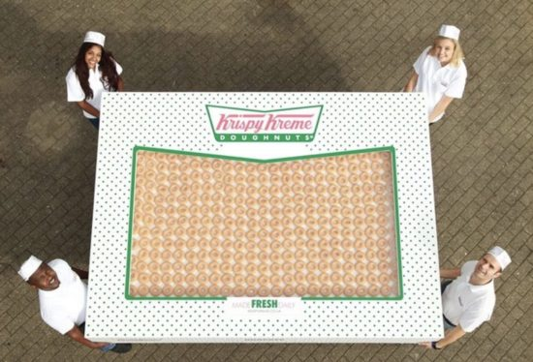 (22x39=858) (I know that the actual box has 2,400. For this being the first time they are seeing such big numbers in division, I think a smaller number is appropriate as it is multi digit by one digit division.)
Teacher will say “What do you notice? What do you wonder?” Provide the students with the following sentence stems: I notice______. I wonder______.
Allow the students one minute to turn and talk with their elbow partners. The teacher will create a class anchor chart: I notice… I wonder…
Teacher will record all student responses on the anchor chart.
ACT 2
Problem to be solved: How many donuts would each of us get to take home if we had this box of 858? (4 people in each table group) T- what do we need to know in order to figure out this problem? Turn and talk with your table groups. Raise your hand and share your ideas. Teacher will provide the following information 1) The amount of donuts in the box. (students will be given a picture of the box with a total listed (858)) 2) Picture of cartoon students (and a total listed as 4 students). T-today we are going to focus on finding the amount of donuts each of us would get if we share with 4 people at our table.
Materials: T will provide students with the handout listed above. T will provide the number of donuts (858) and the number of people that will share donuts (4). T will also provide base ten blocks and place value chips/disks for students to work with hands on. T will provide paper plates for students (4 in each table group).
Student Organization- S will work in groups of 4 or 3 at their tables on the task for 15-20 minutes. T will monitor and adjust as needed.
Questions for Students- Where do you think we should start? What is some information that you already know? How can that information help you with this task? Why? Do you think there’s a way to make this number more manageable? S- may start decomposing the total number of donuts. S- may begin using manipulatives to sort the decomposed number. How can the plates help you? Can you use another manipulative to solve?
Anticipated Responses: Students may say: How many donuts are there? How many people do we have to share with? Students may solve by decomposing the number and breaking their decomposed number into equal groups. They may skip count up by tens and then fives and ones as they create equal groups. They may subtract from the total as they create equal groups in tens, fives and ones. Students could use base ten blocks by ten or even ones. (they may not finish with ones and I would encourage them to find a larger number that may work better.) They could use the place value chips provided to build the total. The students could write on the plates as they add in algorithm to the total.
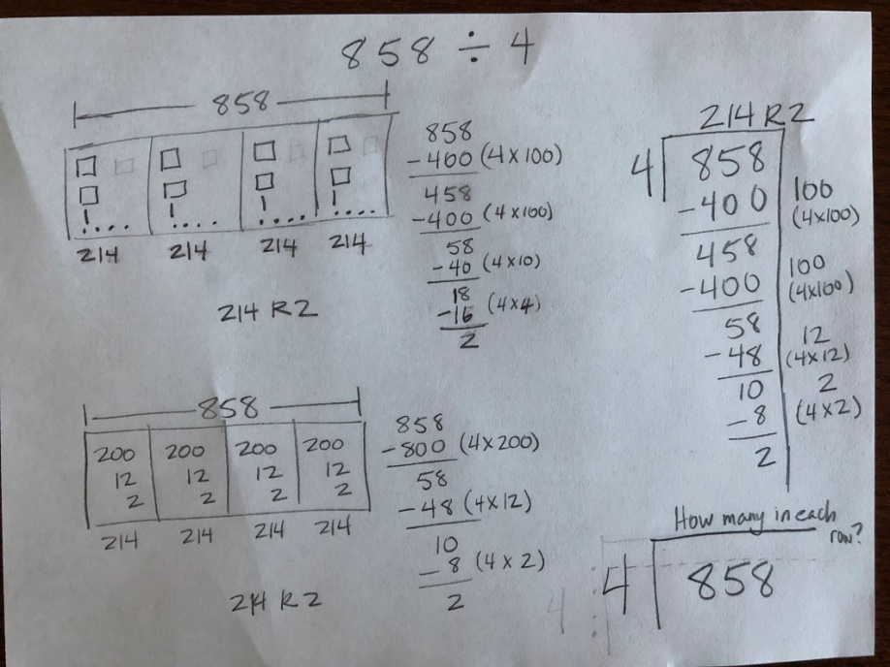
ACT 3: Students will do a gallery walk to see how the other table groups solved. (5-7 minutes) Then each group will take a moment to describe to the class their strategies and how they solved. T will record on white board different strategies used. (3 minutes)
How are these strategies different? How are they the same? Can someone explain a different way they solved? How can we create these strategies in another way?
References: https://tapintoteenminds.com/3act-math/donut-delight/

